**INTELLIGENT DOOR ACCESS MANAGEMENT**

**TEAM CONQUERORS**

TEAM MEMBERS: PRATHYUSHA KASAM

POREDDY PRANATHI

MANASWINI G.S.L

**ABSTRACT**

Mishaps and hazards never come with an invitation. Home security is essential. It protects your personal items from misuse. People also require a sense of peace at home.  It helps to control the front door of your house. The digital and keyless locks provide a sense of protection. Home security is essential for restricting intruders. Also, financial loses can be avoided with the help of smart doors. It is the need of the modern time. The conventional door locks can be easily opened. This makes your house or residential place vulnerable to security threats. Home security is essential because all the precious items are present at the residential place. A person always keeps his home at first priority. One of the key element for the home security is the increasing number of criminal activities across the world. Houses are also targeted as the soft target for the unauthorized uses. This is the reason why home security is essential. Intelligent door access management system puts a barrier towards the criminal actions. Home security is essential because it helps to keep your assets safe in a single location. If your home is secured with keyless door locks then you have the facility to monitor the lock from a distance place. This is the sole benefit for home. Smart door locks are equipped with the safety feature. This helps to monitor the frequent visitors. The main passage is the front door of houses.

TOPIC: **INTELLIGENT DOOR ACCESS MANAGEMENT**

**Hardware:**

* Raspberry pi 3B
* Logitech Camera
* Basic Shield
* DHT11 Sensor
* Servo Motor

**Software:**

* Android Things
* Android studio
* Google’s Firebase cloud

Raspberry pi 3B

* The Raspberry Pi is a low cost, **credit-card sized computer** that plugs into a computer monitor or TV, and uses a standard keyboard and mouse.
* It is a capable little device that enables people of all ages to explore computing, and to learn how to program in languages like Scratch and Python.
* It’s capable of doing everything you’d expect a desktop computer to do, from browsing the internet and playing high-definition video, to making spreadsheets, word-processing, and playing games.
* What’s more, the Raspberry Pi  has the ability to interact with the outside world, and has been used in a wide array of digital maker projects, from music machines and parent detectors to weather stations and tweeting birdhouses with infra-red cameras.
* We want to see the Raspberry Pi being used by kids all over the world to learn to program and understand how computers work.

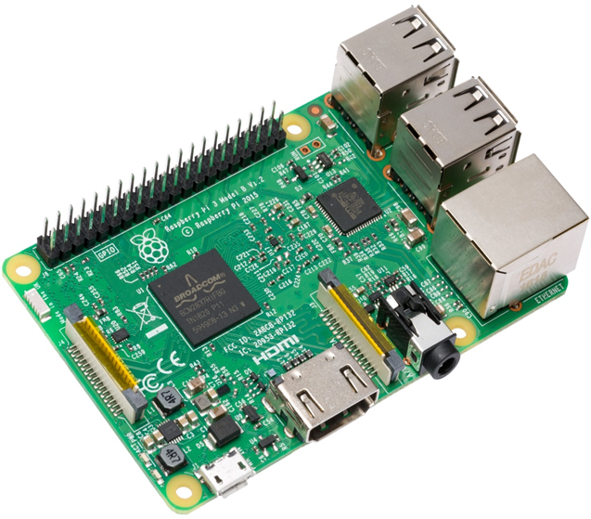

PROJECT HIGHLIGHTS:

* Android Things in Raspberry Pi.
* Interfacing Camera and Push button with Raspberry pi.
* Capturing the image at device and sending to Mobile App Through Google’s Firebase Cloud platform.
* Controlling the door through mobile Application.

**PROJECT DESCRIPTION**

This project will create a smart doorbell notification system so that when a guest clicks on the button, obtains an image of the user via a camera peripheral, and uploads the image and event data to a Googles Firebase cloud and sends a notification with some message to notify that a guest has arrived.

 So from that app we can view who is at the door and we can open and close the door by using the mobile application. By using this system you can know who are knocking your door through the application no matter where you are.

We can flash the Android Things in the Raspberry Pi and access the GPIO pins of Raspberry pi through android programming.

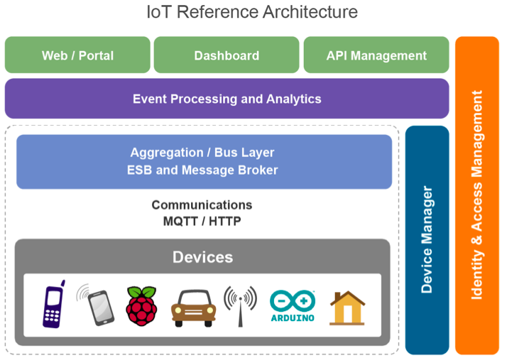

### FINAL CODE: import RPi.GPIO as GPIO import time import numpy as np import cv2 from datetime import datetime import httplib, urllib, os, glob, requests , urllib2 import dht11 fire = 0 gas = 0 temperature = 0  humidity = 0 Doorbell =4 GPIO.setwarnings(False) GPIO.setmode(GPIO.BCM) GPIO.setup(Doorbell , [GPIO.IN](http://gpio.in/)) GPIO.setup(7, GPIO.OUT) p = GPIO.PWM(7, 50) p.start(2.5) instance = dht11.DHT11(pin = 14) global previous_state previous_state = False global current_state current_state = False GPIO.setup(5, GPIO.OUT) GPIO.output(5, GPIO.LOW) GPIO.setup(10, GPIO.OUT) GPIO.output(10, GPIO.LOW) base_url ="

### <http://smartsecurity.thesmartbridge.com/API/get_talkback?userkey=171561096627>" def doorcontrol():     url = "<http://smartsecurity.thesmartbridge.com/API/get_talkback?userkey=71486723251>"     connect = urllib2.urlopen(url)     response= connect.read()          #response = urllib.urlopen(url).read()     print response     try:         if response == "DOOROPEN":             p.ChangeDutyCycle(12.5)  #180°                      if response  == "DOORCLOSE":             p.ChangeDutyCycle(2.5) #0°                      if response  == "LIGHT1ON":             GPIO.output(5,GPIO.HIGH)             print "light1 is on"                  if response  == "LIGHT1OFF":             GPIO.output(5,GPIO.LOW)             print "light1 is off"                      if response  == "LIGHT2ON":             GPIO.output(10,GPIO.HIGH)             print "light2 is on"                  if response  == "LIGHT2OFF":             GPIO.output(10,GPIO.LOW)             print "light2 is off"                   except keyboardinterrupt:       p.stop() def sensors():              gas = GPIO.input(gassensor)     print " GAS STATUS " +str(gas)     fire = GPIO.input(firesensor)     print " fire  STATUS " +str(fire)     result = instance.read()     if result.is_valid():         temperature = result.temperature         humidity = result.humidity         print temperature         print humidity     else:         print "no data from sensor"         temperature = 33         humidity = 44     url2 = base_url + "&field1="+str(temperature)+"&field2="+str(humidity)+"&field3="+str(0)+"&field4="+str(gas)+"&field5="+str(current_state)     print(url2)     f = urllib2.urlopen(url2)     print f.read()     f.close()      def camera():     count =1          current_state = GPIO.input(Doorbell)     current_state1 = 0     print " button state = " + str(current_state)     print " pir state = " + str(current_state1)     if current_state == 0 or current_state1 ==1:         cap = cv2.VideoCapture(0)                  ret, frame = cap.read()         print "Saving Photo"         picname = datetime.now().strftime("%y-%m-%d-%H-%M")         picname = picname+str(count)+'.jpg'         cv2.imwrite(picname, frame)                  url1 = '<http://smartsecurity.thesmartbridge.com/API/image_upload/71486723251>'         files = {'fileToUpload': open(picname, 'rb')}         r = requests.post(url1, files=files)         print r.text         time.sleep(5)         cap.release()         count=count+1      while True:     previous_state = current_state     sensors()     camera()     time.sleep(2)     doorcontrol()     #upload()